**SOFTWARE DESIGN AND DEVELOPMENT**

**Table of content**

Introduction 3

Implementation 3

Conclusion 19

References 20

# Introduction

This is the Student management system in which the application is done based on the requirements of the users. In this the files are stored in the database that would be connected with SQL for storing the details. The files would be connected to each other for storing the details for delivering the output of the system. This is based on the student as well as the teacher and it is completely based on the details of the users. In this, the exam paper is added to the system and it could be updated by the admin at any time and the details are stored in form of different tables. This also helps in maintaining the requirements of the system as it could deliver the required data into the given fields.

# Implementation

This would describe the implementation covered for completing the application process that helps in delivering the requirements of the system with the help of users.

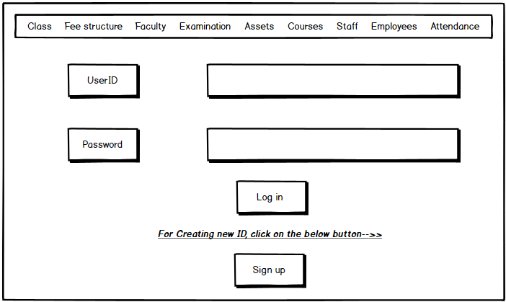

**Figure 1: Prototype**

(Source: self)

The above figure describes the prototype that is designed using the files of the entire system. It is describing the login process as well as the complete process of the system.

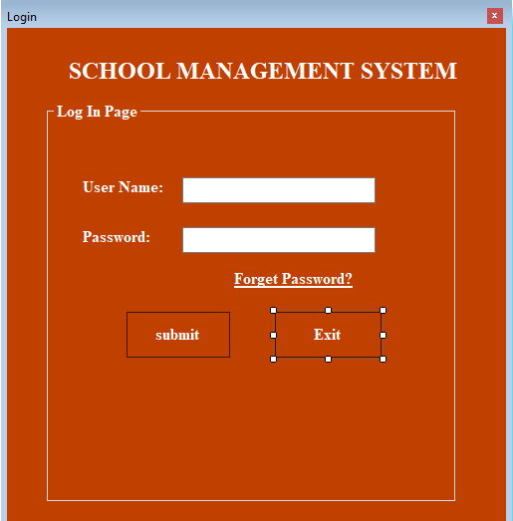

**Figure 2: Login page**

(Source: self)

In the above figure, the login page of the school management system is given. The login page consists of the user name and password. After entering the user name and password there is a submit option present (Jadhav, and Nandedkar, 2020). There is also an exit option present. The username would their give their user name and password and after filling in the required details they would be able to the Student Management system.

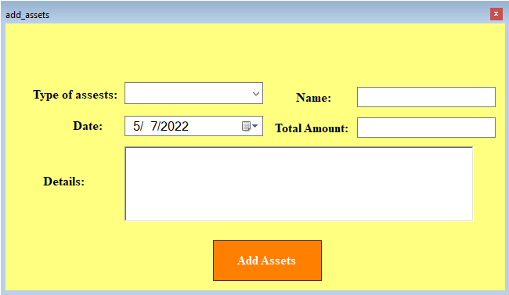

**Figure 3: Assets**

(Source: self)

The above figure describes the number of assets added to the system that could be used for the system to enhance its requirements. This also checks the complete requirements of the system.

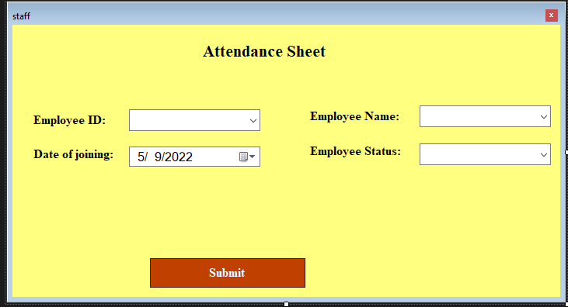

**Figure 4: Attendance sheet**

(Source: self)

The above figure describes the attendance sheet of the system. It is important as it checks the availability of the teachers in the system.

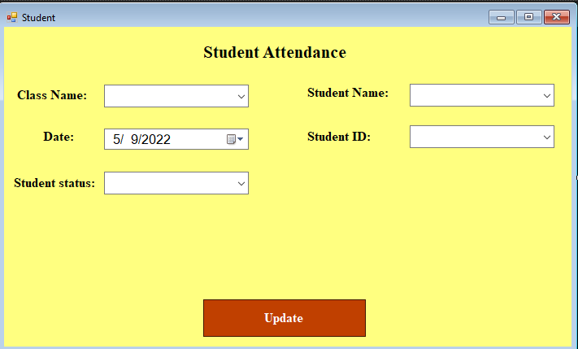

**Figure 5: Student Attendance**

(Source: self)

The above figure describes the attendance of the students in the system. The teachers get access to this function as they check the attendance of the student in the class and they have to keep the record.

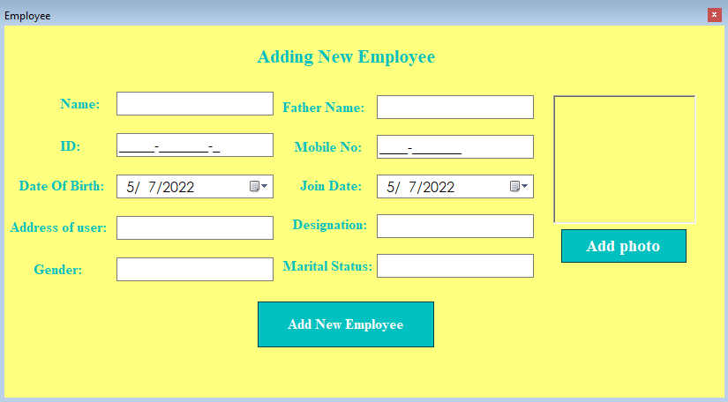

**Figure 6: Adding a new employee**

(Source: self)

The above figure describes the details of adding a new employee to the system. This checks the background status of the employee as they are relevant for the job or not. This also checks the entire details date of birth, address, and marital status before confirming their employment in the system.

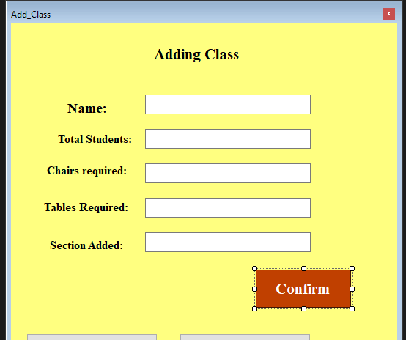

**Figure 7: Adding a new class**

(Source: self)

The above figure describes the class is added to the system. In case there are extra requirements for the class, from where it can be added to the system.

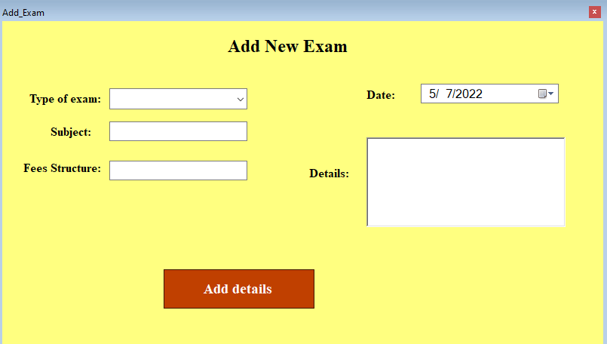

**Figure 8: Add exam details**

(Source: self)

The above figure describes the details of the exam that are added to the system. This also includes a detailed description of the examination fees.

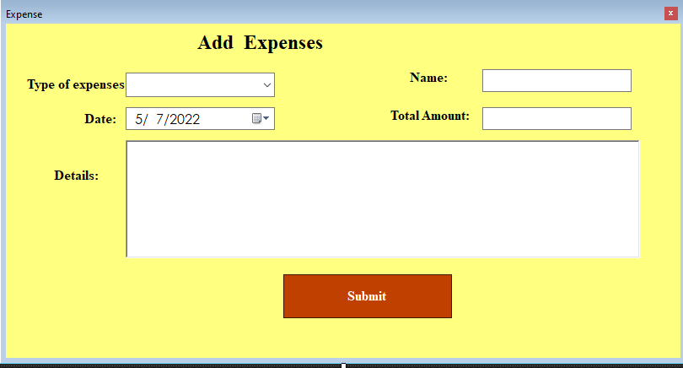

**Figure 9: Add expenses**

(Source: self)

The above figure describes the total expense that is spent in the entire month.

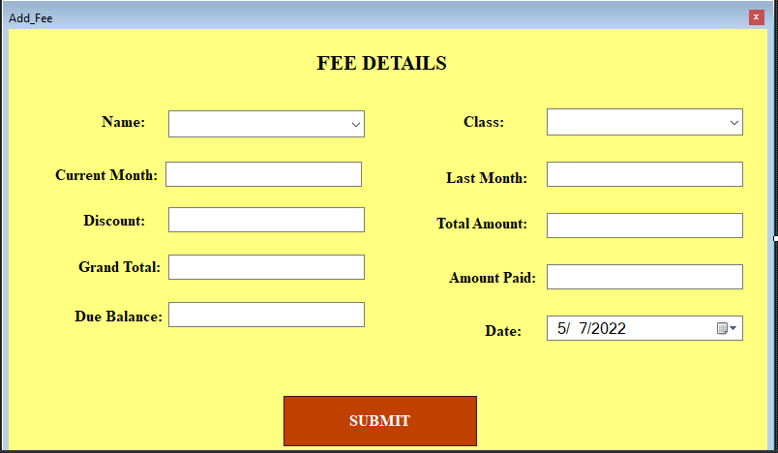

**Figure 10: Fee details**

(Source: self)

The above figure describes the fee details of the system. The students, as well as the teachers, can view the details of the fees.

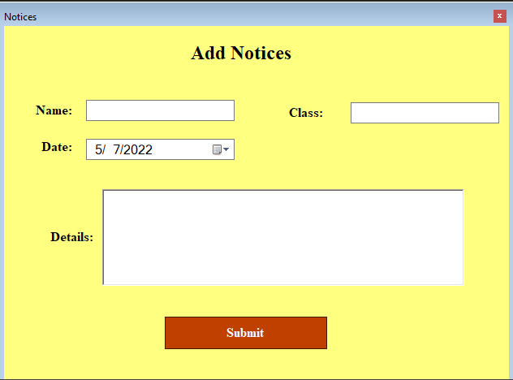

**Figure 11: Notices**

(Source: self)

The above figure describes the notices that are generated by the system in case o any issues changed in the system.

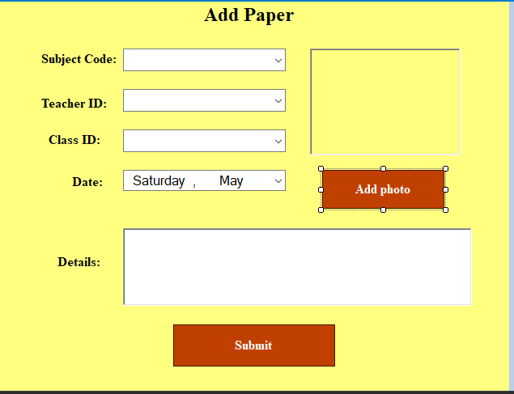

**Figure 12: Add paper**

(Source: self)

The above figure describes the paper that is added for the exam that is going to start in that semester.

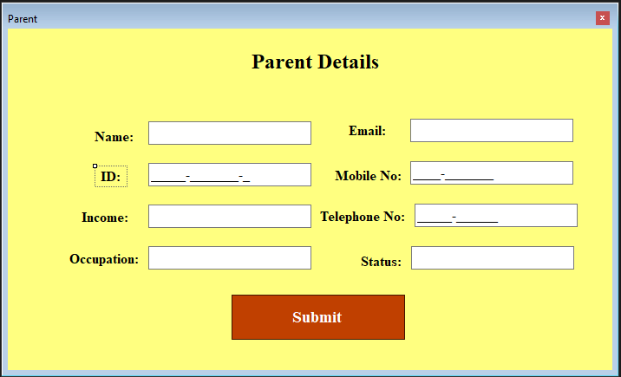

**Figure 13: Parent details**

(Source: self)

The above figure describes the details of the parents of the students. this is important for the system as it stores the information of the parents so that they can easily get access to them in the required time.

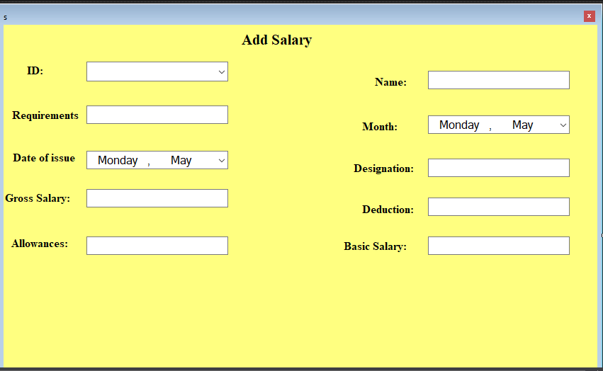**Figure 14: Add salary**

(Source: self)

The above figure describes the salary details of the system. This page is showing the details of the salary like the net payable amount and these are stored in form of tables.

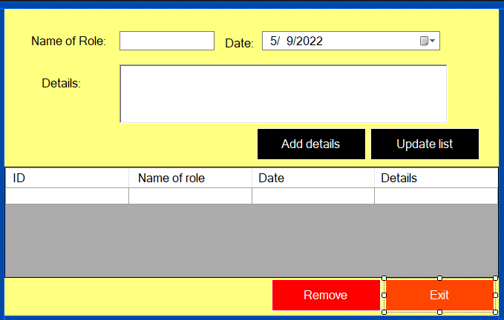

**Figure 15: New role**

(Source: self)

The above figure describes the new role that is added to the system that would be useful for increasing the assets in the company.

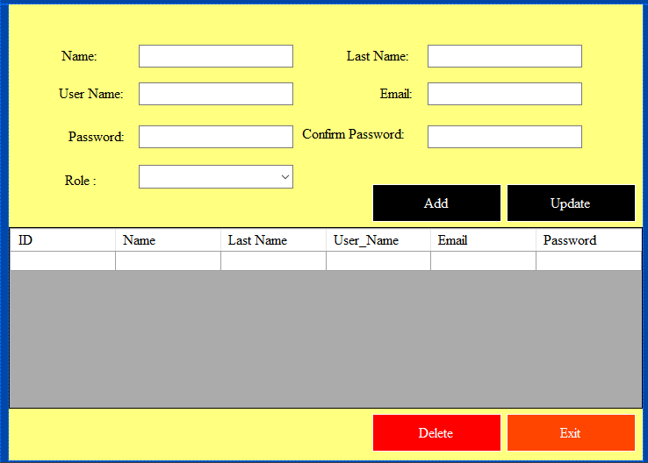

**Figure 16: New user**

(Source: self)

The above figure describes adding a new user to the system. The users are added and after they can log in from the portal by filling in their login credentials.

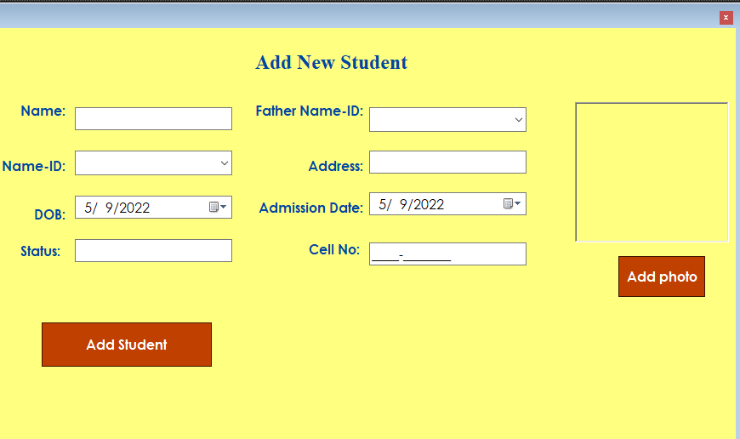

**Figure 17: New student**

(Source: self)

The above figure describes adding a new student to the class. This helps in generating the requirements in the user as the admin could be able to add a new student in the portal anytime and this would be visible to the student (Qiu, 2018).

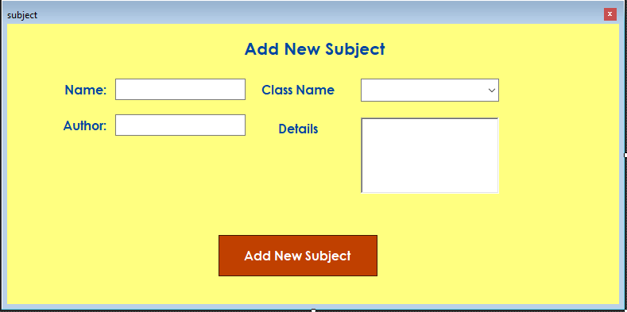

**Figure 18: add subject**

(Source: self)

The above figure describes the addition of a new subject to the system (De Silva, 2021). This form is created for adding a new subject to the system that could be used for delivering the requirements in the system.

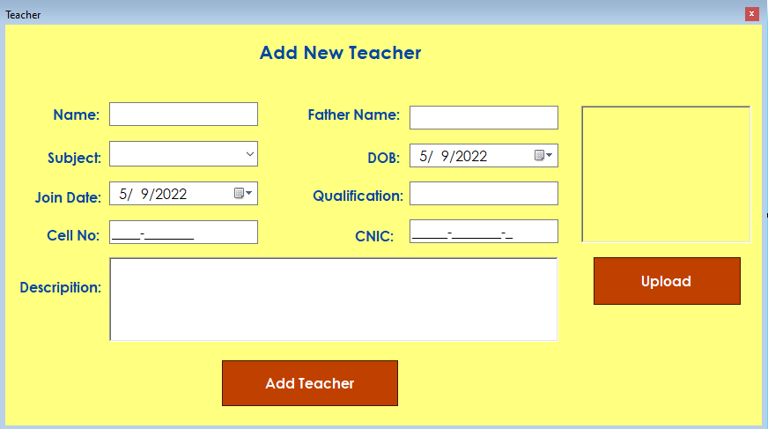

**Figure 19: Add new teacher**

(Source: self)

The above figure describes the values of adding a new teacher to the system. This helps in completing the process of taking new teachers into the system which would benefit for the system as it could decrease the stress on other teachers (Onyishi, and Igbinoba, 2021).

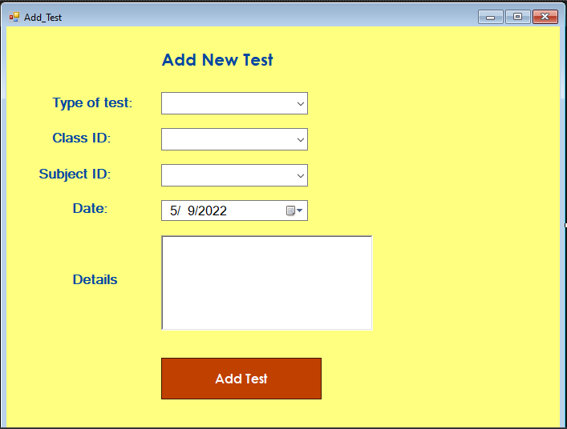

**Figure 20: Add test**

(Source: self)

The above figure describes the add test form, in this, the teacher would be able to add the test for the test (Iyanda, Ninan, and Odejimi, 2018). In this, the subject Id is mentioned, the type of test and also the subjects, the date of the exam, and details about the exam.

# Conclusion

This is the system that is based on a visual studio where the user could store details in the tables for delivering the requirements in the system. It also helps in generating the requirements based on the data that is stored in the system. It is also over useful for generating the system that could connect the details of the students as well as the teachers for adding their values that could be easier for the system to evaluate the values in the system.

# References

De Silva, P.H.A.U., 2021. *STUDENT MANAGEMENT INFORMATION SYSTEM FOR NATIONAL INSTITUTE OF SPORTS SCIENCE* (Doctoral dissertation).

Iyanda, A.R., Ninan, O.D. and Odejimi, D.J., 2018. Students Conversation Management System. *International Journal of Education and Management Engineering (IJEME)*.

Jadhav, V.P., and Nandedkar, V.M., 2020. Development of Database Management System for Small Scale Manufacturing Industry.

Onyishi, D.U. and Igbinoba, C.K., 2021. Design and implementation of a biometric students’ time and attendance logging system. *Nigerian Journal of Technology*, *40*(3), pp.484-490.

Qiu, J., 2018, August. Design of psychological data management system for university students based on Data Mining. In *2018 International Conference on Virtual Reality and Intelligent Systems (ICVRIS)* (pp. 490-493). IEEE.